How to Access Agency Express Monthly Report Data in Neighbor Intake
- Click on the menu bar in the top right corner of the home screen. Under the “Reports” header, click on “Summary Statistics.”
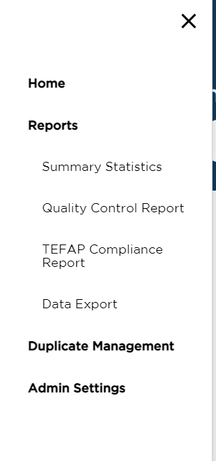

- Click on “Agency Attributes” in the list of available reports.

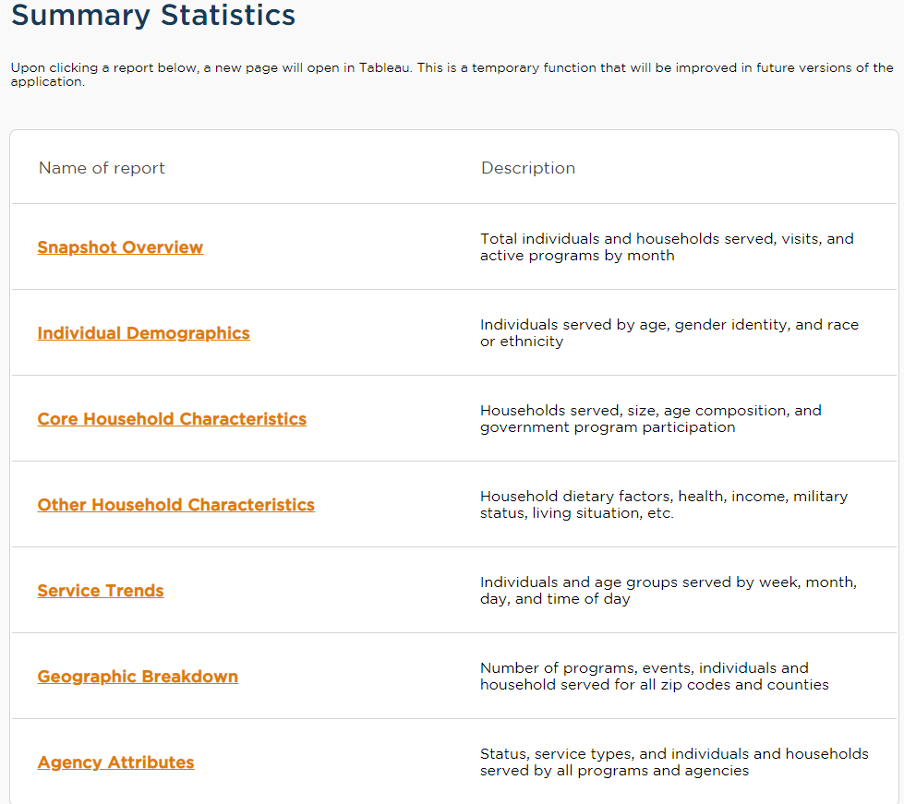
- NUMBER OF HOUSEHOLDS SERVED: The number of new households served will be on the bottom of the screen in the section that says “New Households (Unduplicated).” Calculate the continued number of households served by subtracting the number of New Households (Unduplicated) from Total Households (Unduplicated). Make sure the start date and end date filters are correct.

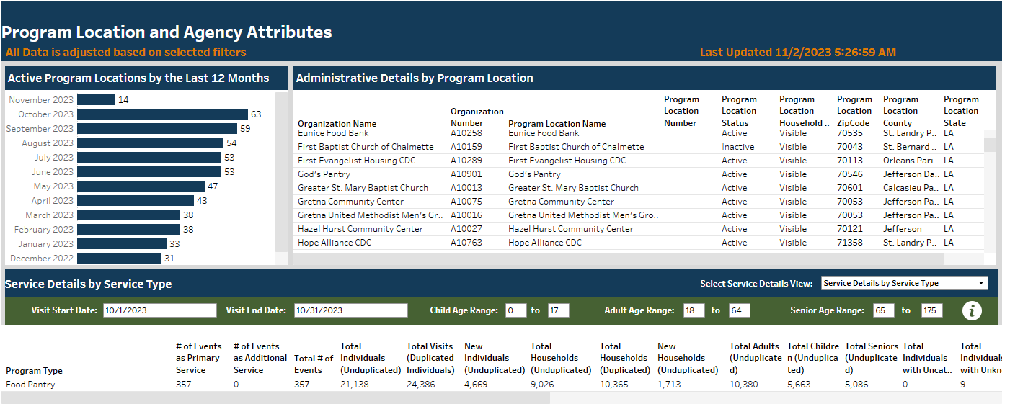
- NUMBER OF CHILDREN SERVED: Make sure the start date and end date filters are correct. Drag the horizontal scroll bar at the bottom of the report to the right, so you can view the necessary fields. The number of new children served will be in the box that says “New Children.” Calculate the continued number of children served by subtracting the number of New Children from Total Children (Unduplicated).
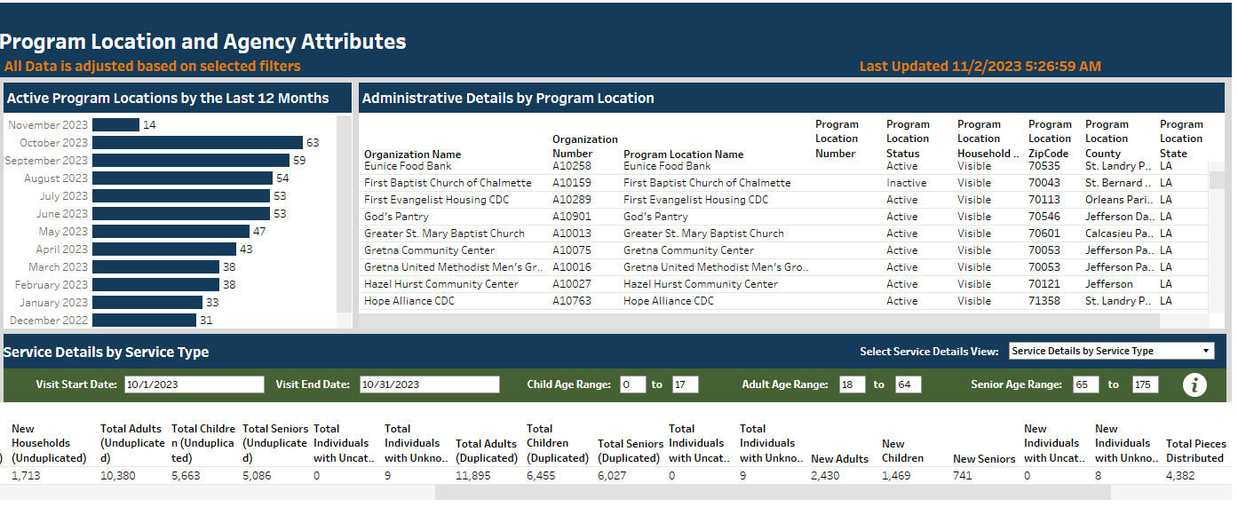
- NUMBER OF ADULTS SERVED: Make sure the start date and end date filters are correct. In the “Adult Age Range” filter, change the upper limit to 64. The number of new adults served will be in the box that says “New Adults.” Calculate the continued number of adults served by subtracting the number of New Adults from Total Adults (Unduplicated).

- NUMBER OF SENIORS SERVED: Make sure the start date and end date filters are correct. In the “Senior Age Range” filter, set the lower limit to 65. The number of new seniors served will be in the box that says “New Seniors.” Calculate the continued number of seniors served by subtracting the number of New Seniors from Total Seniors (Unduplicated).

