USDA Audit Instructions

When the state representative from the USDA is onsite to audit your agency, you will need to be able to perform the following tasks: pull a list of clients who were denied from receiving USDA food, pull a distribution list, and find a client’s application.
How to Pull a Denial Report
- Click on the menu bar in the top left corner of the screen

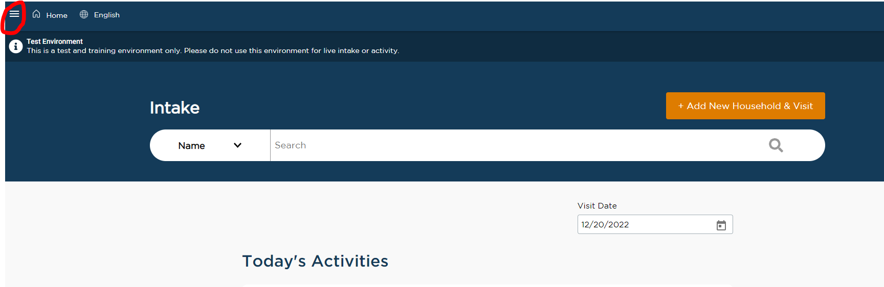

- Click on “TEFAP Denial Report”
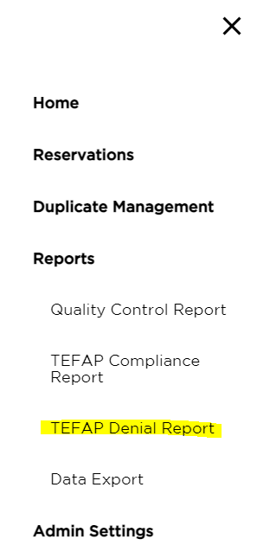

- Enter dates in the “Date Range” boxes and click “Run Report.”
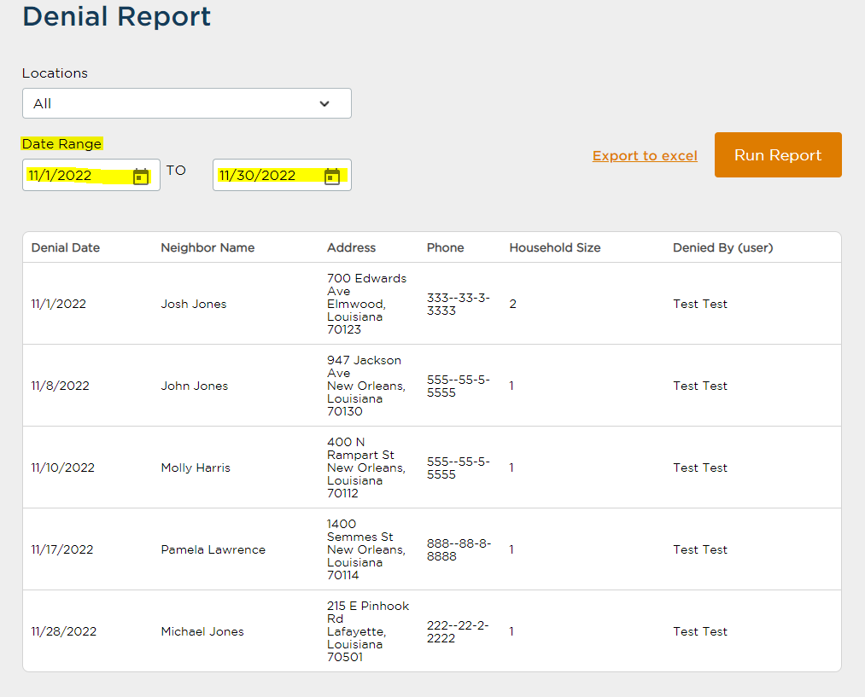
How to Pull a Distribution List
- Click on the menu bar in the top left corner of the screen

- Click on “TEFAP Compliance Report” in the menu screen

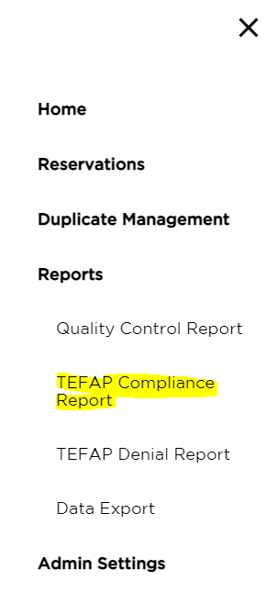

- Enter dates in the “Date Range” boxes and click “Run Report.”

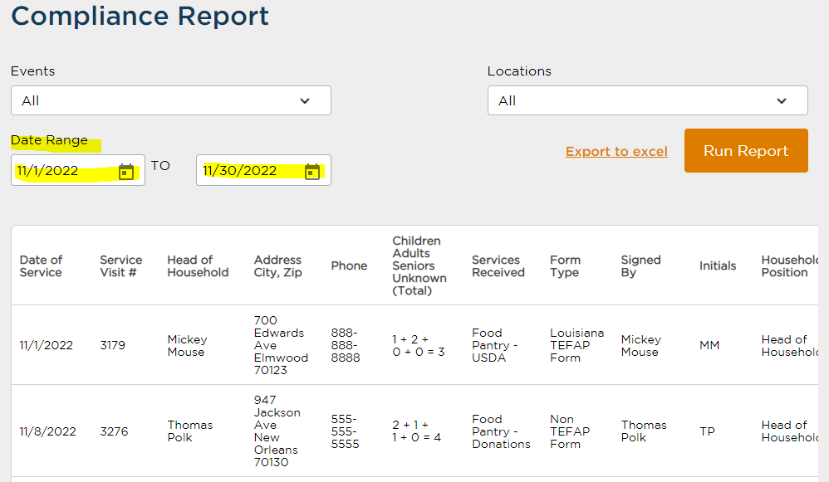

How to Access a Client’s Application
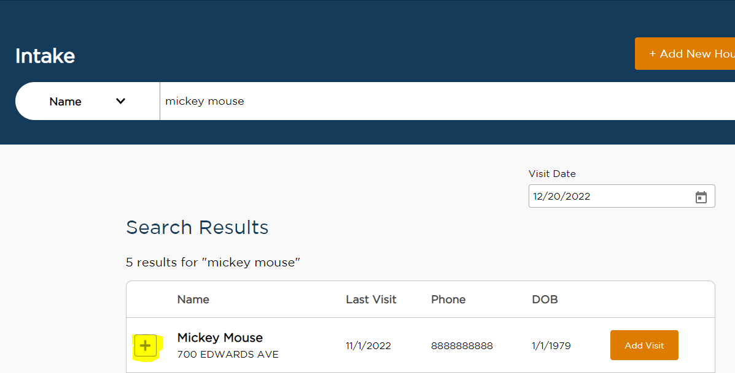
- Type the client’s name into the search bar on the home page. Click on the plus sign to the left of their name.

- Click on “View Full History” in the bottom right corner of the client’s expanded information

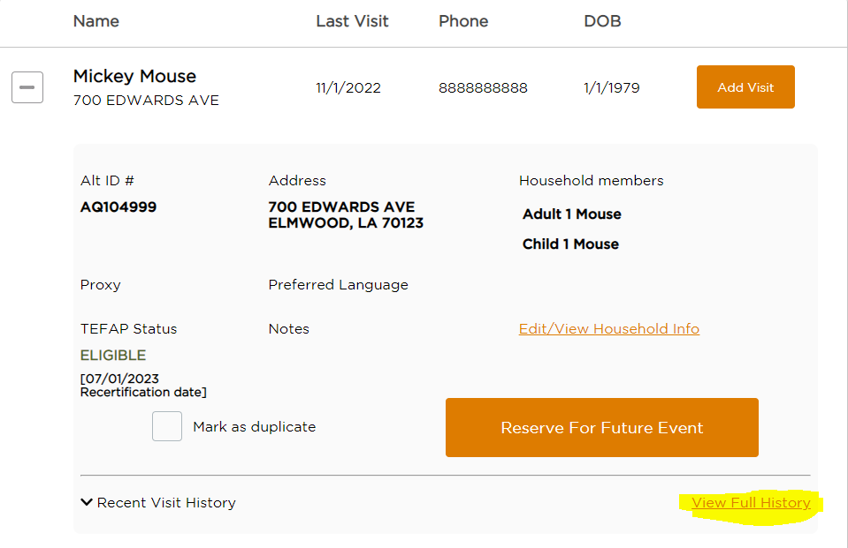

- Click on “View” next to the desired date

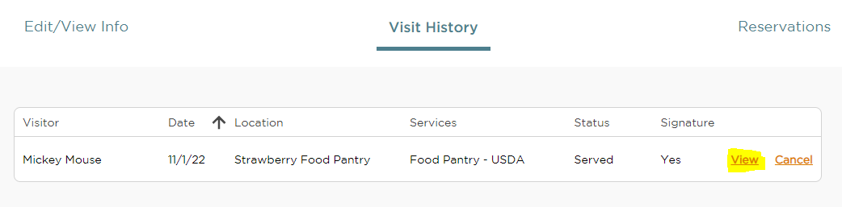

- Show the application to the USDA representative
