Neighbor Intake Instructions for Non-USDA Mobile Pantries

How to Add a New Neighbor
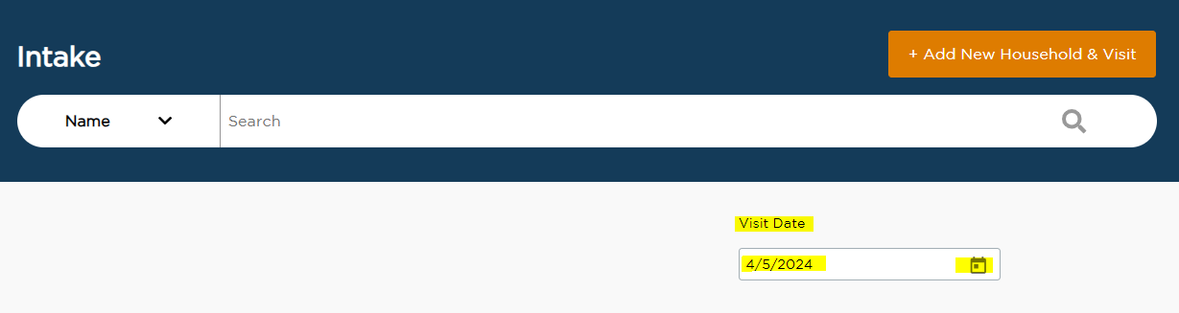
- Check the Visit Date to make sure it matches the day the neighbor came to the pantry. Change the date if necessary.

- Click “Add New Household & Visit”
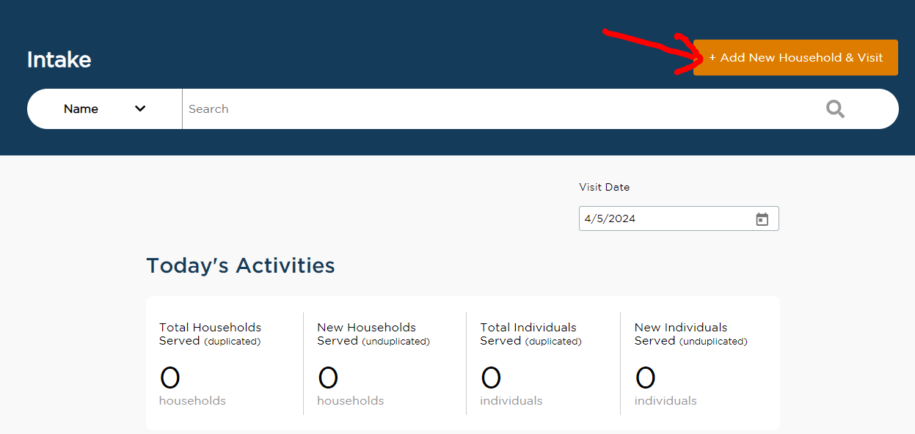

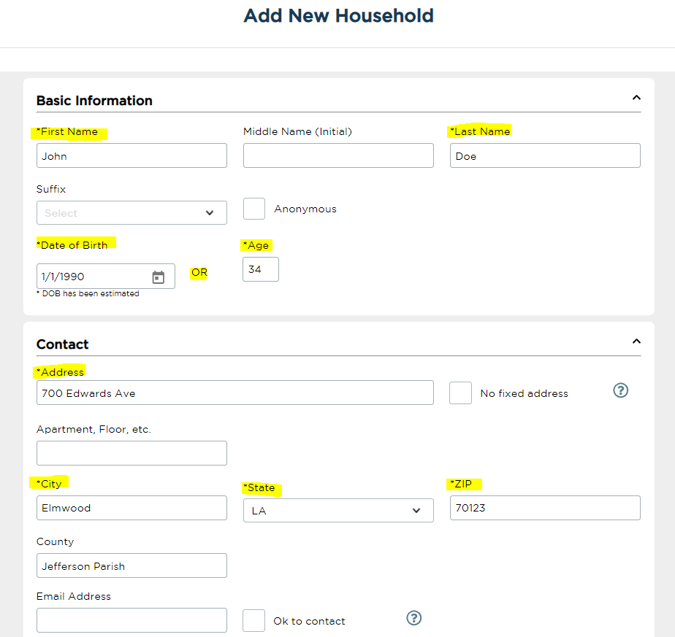
- Type the client’s information into the required fields

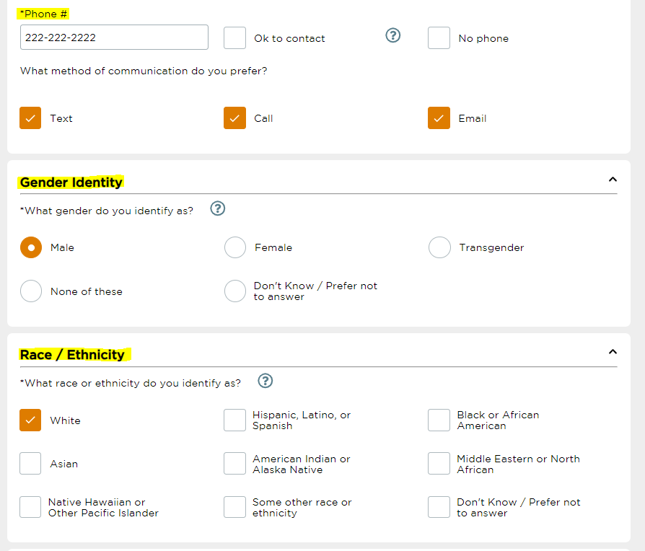

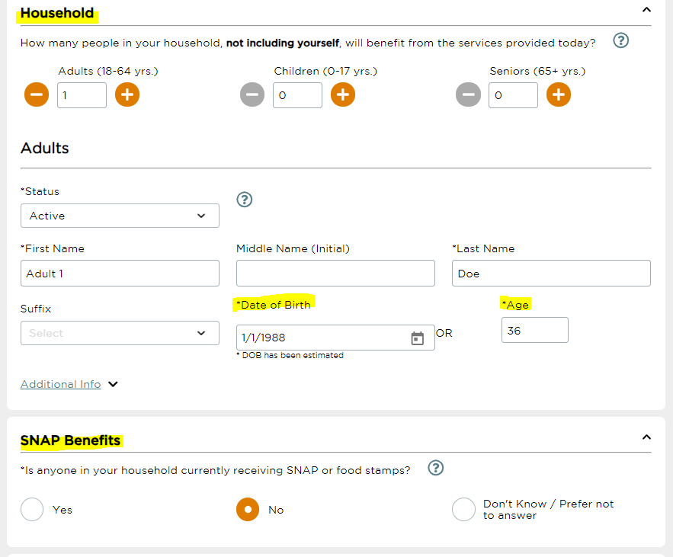

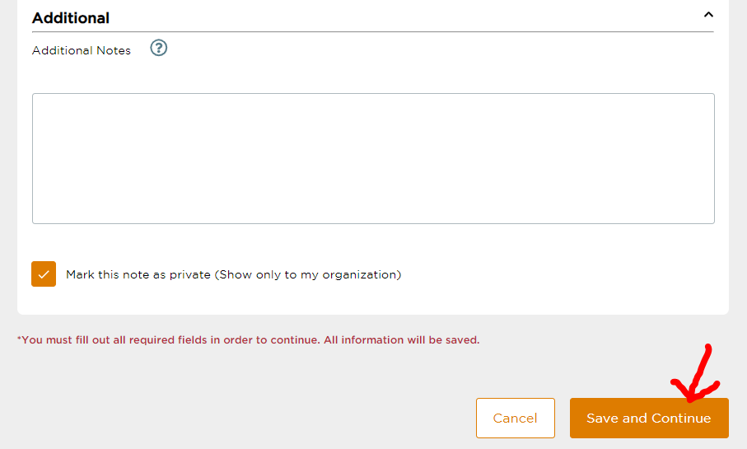
- Click “Save and Continue” at the bottom of the page

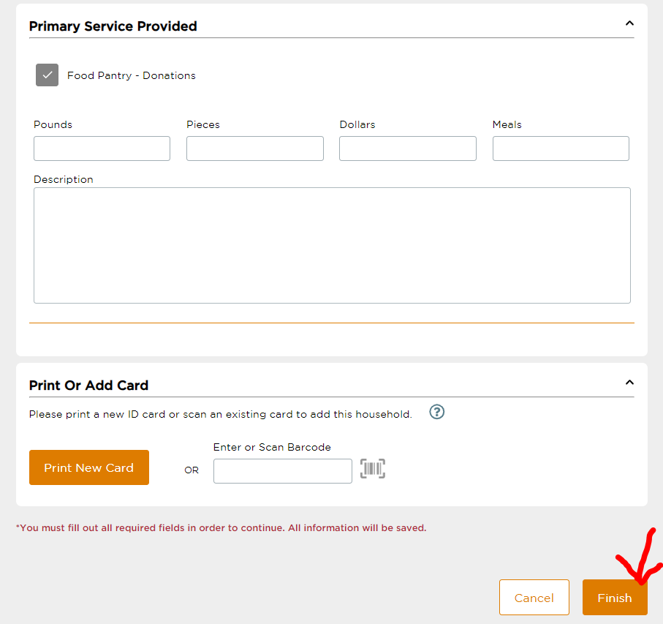
- Click “Finish” at the bottom of the page
- Click “Done”

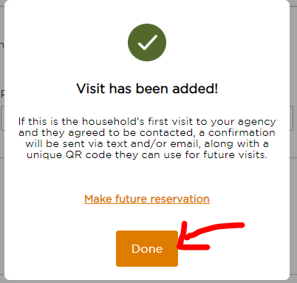

How to Serve a Returning Neighbor
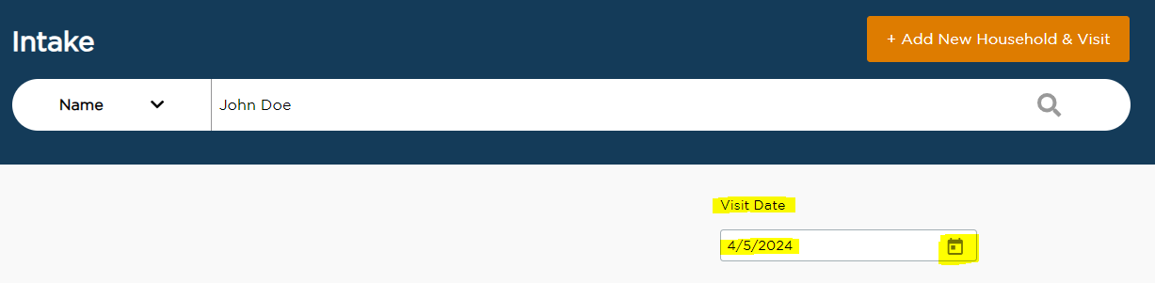
- Check the Visit Date to make sure it matches the day the neighbor came to the pantry. Change the date if necessary.

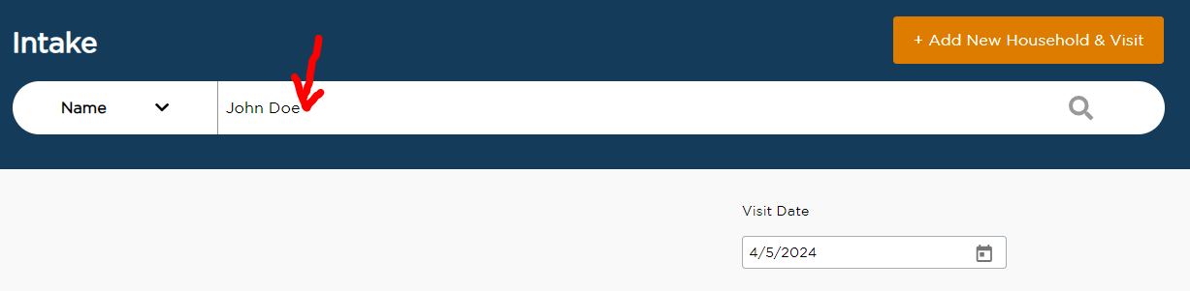
- Type the neighbor’s name into the search bar and hit the Enter key

- Click “Add Visit” next to the neighbor’s name
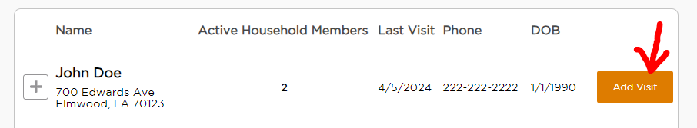

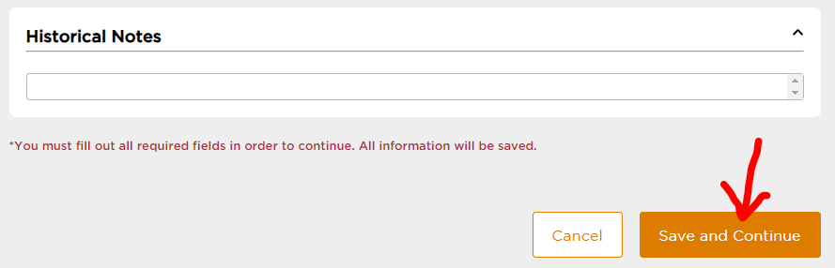
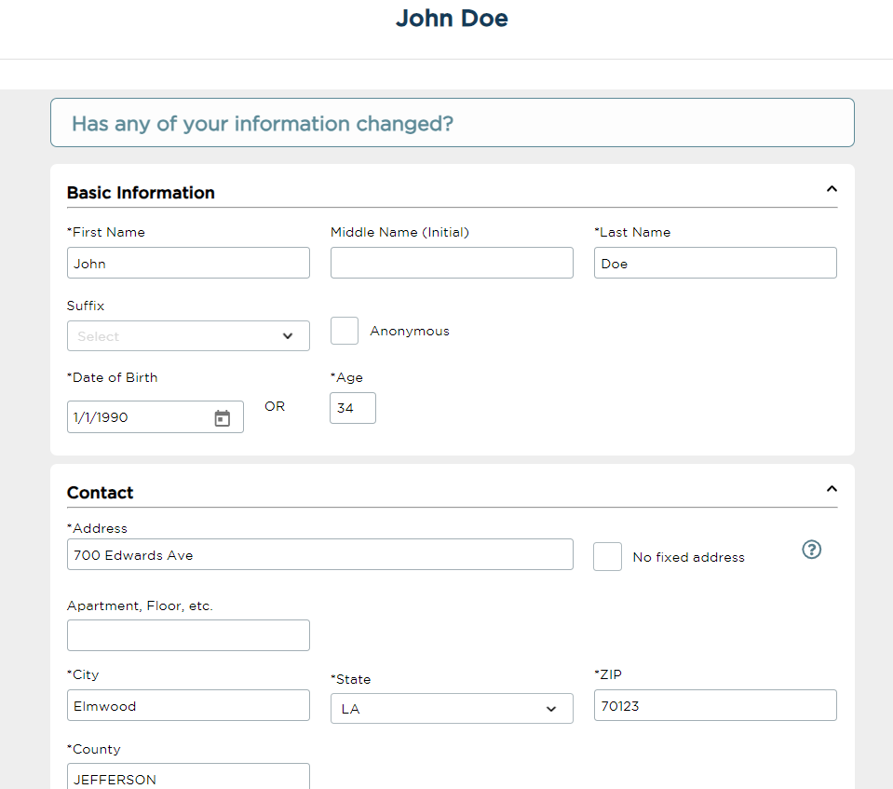
- Scroll to the bottom of the page and click “Save and Continue”

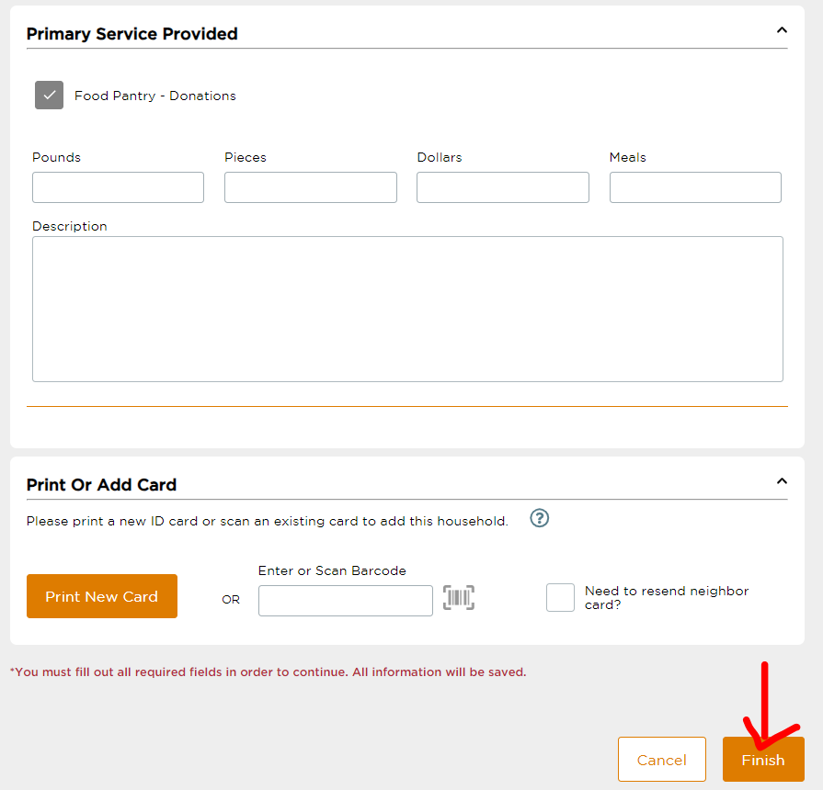
- Click “Finish” at the bottom of the page
- Click “Done”

